Church Growth Project Phase 1 complete
Perry Hall Methodist Church have completed Phase 1 of our Church growth project.
Our aim was to deliver a growth plan to expand church and community use of our church buildings and outside space.
Due to increased community use, we wanted to improve the accessibility to our premises for vulnerable members of our community.
We were also concerned that in terms of our health and safety responsibilities certain areas were no longer safe.
Phase 1 has seen the tarmac on our existing car park removed and new edging stones and tarmac laid.
Due to the growing size of the Church congregation and the number of community groups that use our premises, we have been parking on a lawned area adjacent to the tarmac car park.
The lawned area has been removed and replaced with grasscrete, which will allow us to continue to use this area for parking but retain the existing look and feel.
Grasscrete also has the advantage of being made from re-cycled plastic and allows "Sustainable Urban Drainage".
During the Covid pandemic, while the building was closed, we were able to carry out some activities in our outdoor space for the benefit of our congregation and the local community and we are now busy planning what temporary or permanent installations for prayer and reflection we can install in our grounds now the car park is complete.
- During Advent 2020 we installed a “Christmas tree” of praying hands, on which members of the congregation, members of our user groups, children from Dorrington School and members of the local community were invited to write prayers. These were laminated and fixed to the “tree”, where they remained until Lent 2021. This initiative was much appreciated by the local community and won us a community award.
- During Holy Week 2021 we replaced the “tree” with crosses on which people were invited to write their griefs on teardrop shapes, and their hopes and thanks on flower shapes. Again, this has been much appreciated by the local community, in particular by the family of a boy who was killed in a hit-and-run accident opposite the church. We also installed an Easter garden.
- At the beginning of Lent, we spray painted a prayer labyrinth on the car park. This was necessarily small in order to avoid the potholes!
- We held outdoor services on Christmas Eve 2020 and Easter Day 2021 and because of the Covid restrictions we were able to do so safely by placing chairs strategically to avoid the dangerous areas. Our new safe surface will allow us to welcome larger numbers of people.
We would like to thank the following organisations that have generously given money to help us complete the work.
Allchurches Trust
Grimmitt Trust
Birmingham Methodist District
Birmingham Methodist Circuit
Phase 2 of the project will see three existing rotting wooden notice boards replaced with a single metal board.
Phase 3 will be the installation of an electric vehicle charging point to comply with a condition of our planning permission.

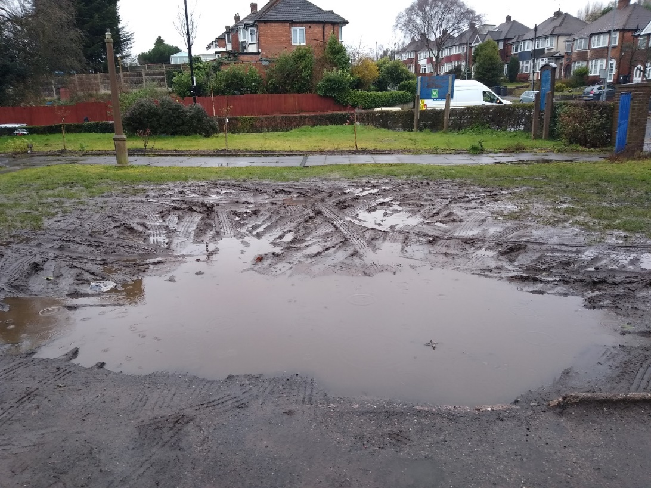
BEFORE

AFTER
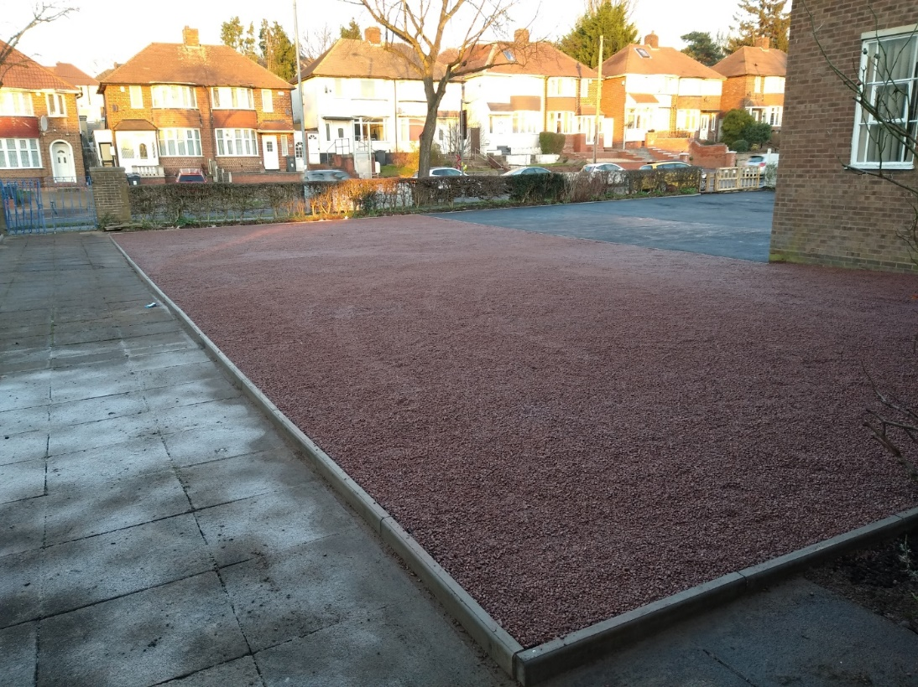

BEFORE

AFTER
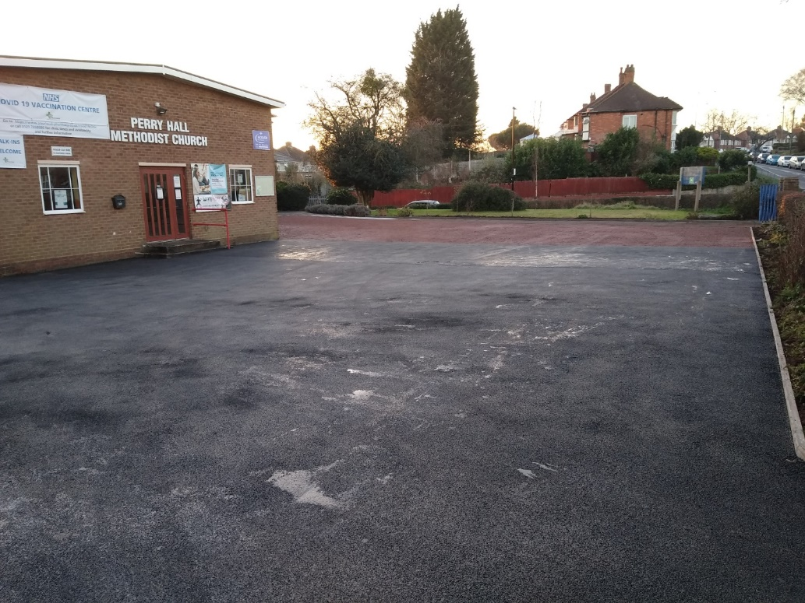
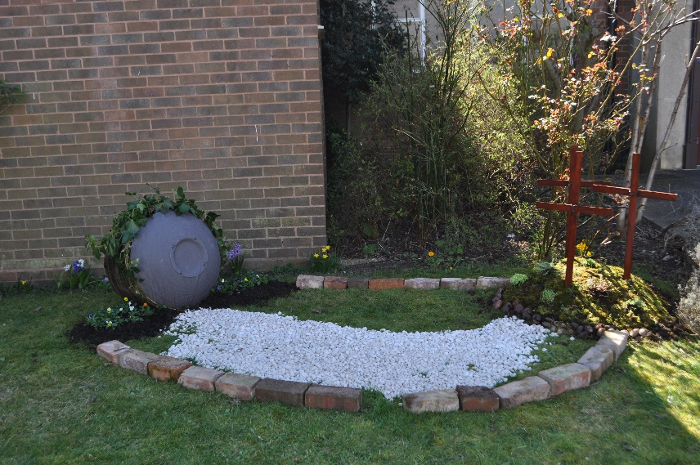
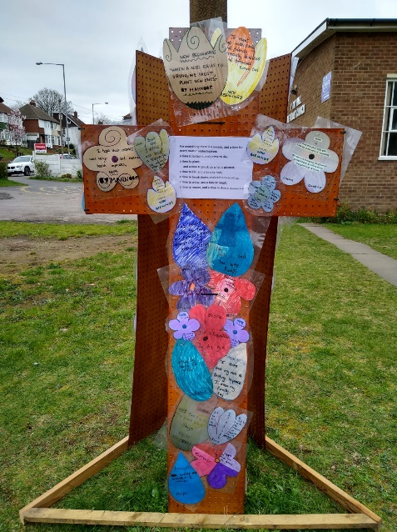

Easter Garden
Easter Crosses - teardrops of grief, flowers of hope

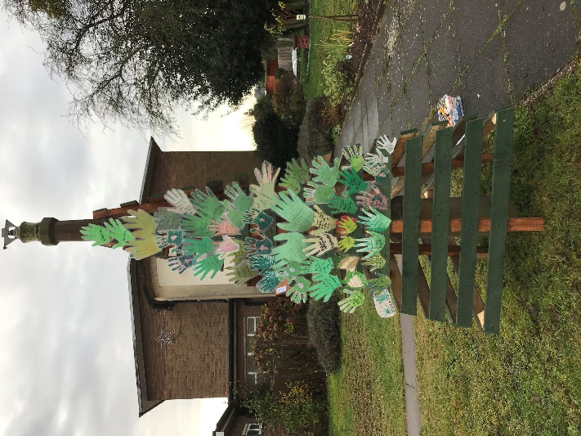

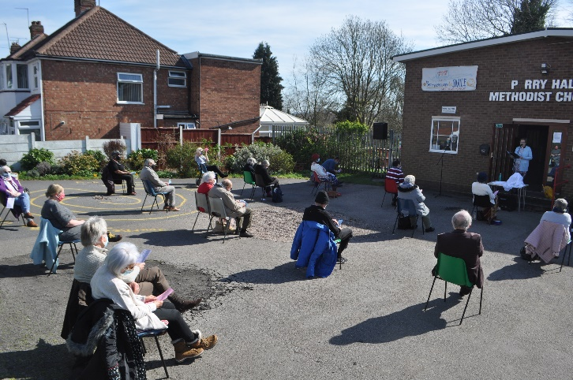
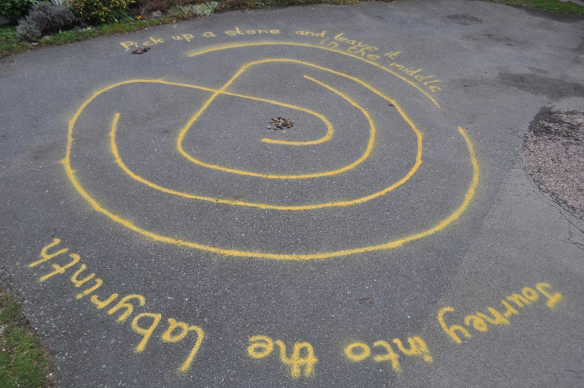
Easter Day Outdoor Service
Christmas Praying Hands
Prayer Labyrinth

