Meditations with music

The following meditations were written for us in evening devotions for the Birmingham District ministers’ retreat in 2017.

The Bible readings set a context.

The meditations were written to be read before listening to the music, but if helpful can be referred to during the music to help focus.

Letting go, letting God.

Bible Reading:
Matthew 4: 12 - 16

Meditation

The bell tolls,
a time for letting go,
a letting go of that which gets in the way,
of that which holds you back.
A release into the deeper realities,
into the deeper complexities,
A release into the heart of God,
into the glimmer of light
shining in the darkness.
into the all surrounding love
that encompasses all.
Music: Arvo Pärt: Cantus in memoriam Benjamin Britten
https://www.youtube.com/watch?v=sp2oxWdRMuk

Generation gap?

Reading:

Matthew 9: 16 - 17
Matthew 13: 52

Meditation:

A clash of cultures,
Ancient choir and modern jazz,
The new transforms the old,
opening up undreamed of possibilities;
the old gives depth to the new
undergirding with the wisdom of the ages.
In contrast, yet in harmony
breathtaking, yet challenging beauty emerges.
There are tensions in the collision,
sometimes hard to live with,
but essential for creativity.
God’s creativity
works with the tensions
for a divine purpose,
can we?

Music

Officium: Hillyard Ensemble and Jan Gabarek

https://www.youtube.com/watch?v=0_dmQ7-_b-c
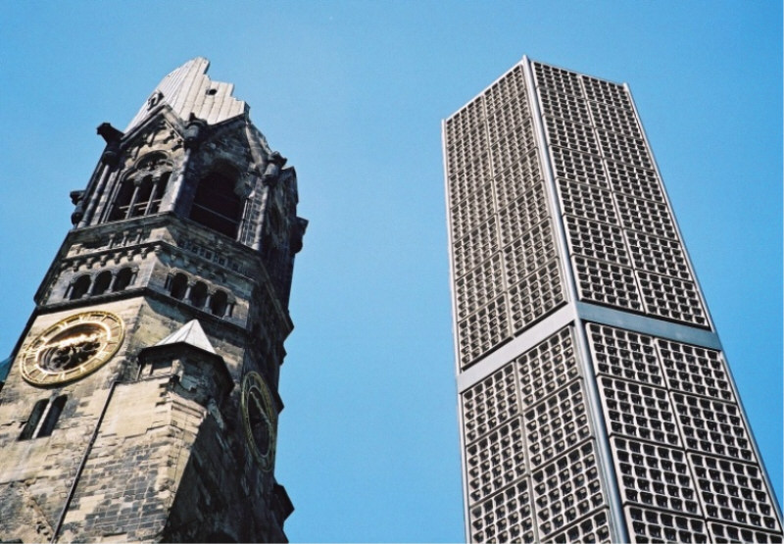

The depth of ambiguity

Reading:
Luke 9: 23 - 25

Meditation:

Happy or sad
teasing uncertainty
context is all
Strange how potent cheap music is
Moving to tears
invoking memory, association,
reminding of the beauty in ambiguity,
pointing to a deeper sense of what is real.
touching on what really matters,
gaining life and losing it,
a cross the symbol of glory
the divine mystery at the heart of creation.

Music:

La, la land: Epilogue

https://www.youtube.com/watch?v=W7QLfIgniZs&index=13&list=PLywiNEAPE4I9mIv_edkzGeyJkeJmB9b8J

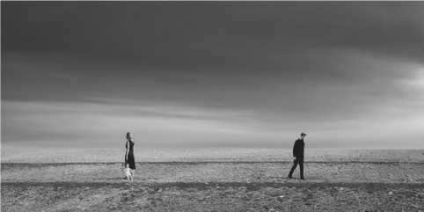

Suggested hymn: StF 485: When we are living

A shaft of light
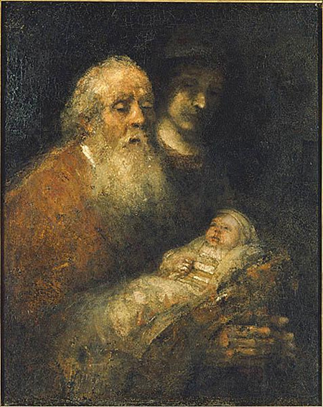

Reading: Luke 2: 22 - 32

Reflection

An old man in a dark temple
Looking for light
Promised the light
And there is a family,
with a new born child.
And into his hopes,
into his fears,
a light shines
In his ordinariness
he glimpses the extraordinary.
‘A light to lighten the gentiles’

And later we hear the voice of this child:
’While I am in the world,
I am the light of the world’
But is he in the world now?
We see the darkness,
We fear the uncertainty
Where does the light break in?
Where does it shine on us?
How does the light shine through us?

And shining what does it show?
A lighting up of the ordinary,
the humdrum made sacred,
as the oboe cuts into the
rum-ti-tum of the clarinets,
so a shaft of his light transforms
into wondrous beauty.

But light also uncovers darkness,
the darkness of poverty,
of injustice, of hatred,
of divisive power.
the light of Christ reveals it for what it is.

Shining light in dark places
raises questions,
sharpens issues
taking on the powers of darkness
needs courage.

Can we long for the light of Christ,
the light of love, of peace, of justice,
Unless we are prepared let it shine through us?

Music: Adagio from Serenade for 13 wind instruments: Mozart

https://www.youtube.com/watch?v=5BWn1KuXGVM

